**Revision History**

|  |  |  |  |  |
| --- | --- | --- | --- | --- |
| **Section** | **Edition** | **Revised by** | **Date** | **Description** |
| All | 1.0 | Jans Lien. | 07/25/2024 | New |

**Index**

**1****Purpose :** 3

**2** **Scope：** 3

**3** **Definition：** 3

**4** **Reference：** 3

**5** **Contents：** 3

5.1 Download WeatherMap Plugins 3

5.1.1 Connect to https://github.com/howardjones/network-weathermap/ 3

5.1.2 Click “Code” button. 3

5.1.3 Select “Download Zip” 3

5.2 Put WeatherMap ZIP file to Cacti Server via SFTP. 4

5.3 Unzip WeatherMap Plugins 4

5.4 WeatherMap Installation & Active 5

5.5 WeatherMap Configuration 5

5.6 WeatherMAP Setup 6

5.7 WeatherMAP Background change. 6

5.8 WeatherMAP Node Setup. 7

5.9 WeatherMAP Link Setup. 8

5.10 WatherMAP Dashboard: 10

**6** **Attachment：** 10

1. **Purpose :**

This SOP provides Cacti WeatherMAP plugins installation and setup for users’ reference.

1. **Scope：**

TPV.

1. **Definition：**

None.

1. **Reference：**

None.

1. **Contents：**
   * 1. Download WeatherMap Plugins
        1. Connect to <https://github.com/howardjones/network-weathermap/>
        2. Click “Code” button.
        3. Select “Download Zip”

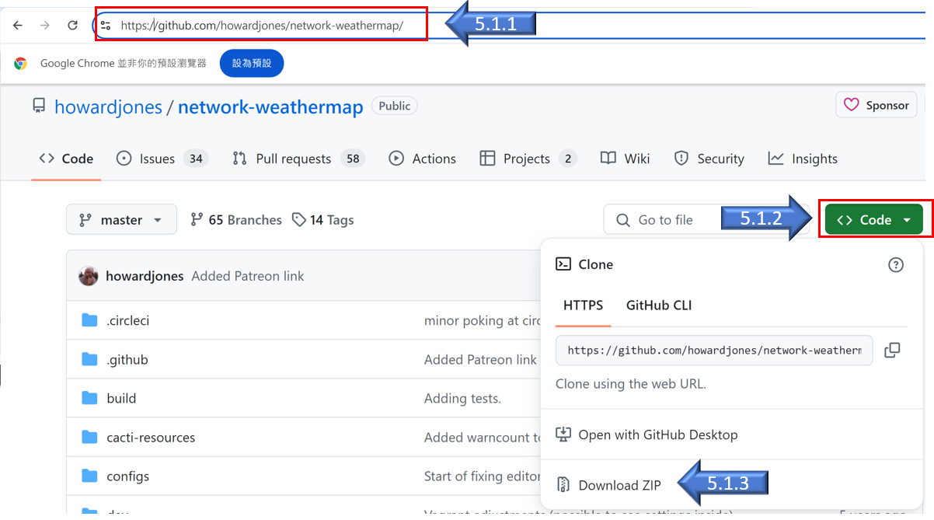

* + 1. Put WeatherMap ZIP file to Cacti Server via SFTP.

Put WeahterMAP zip file to /usr/share/cacti/plugins on Cacti server.

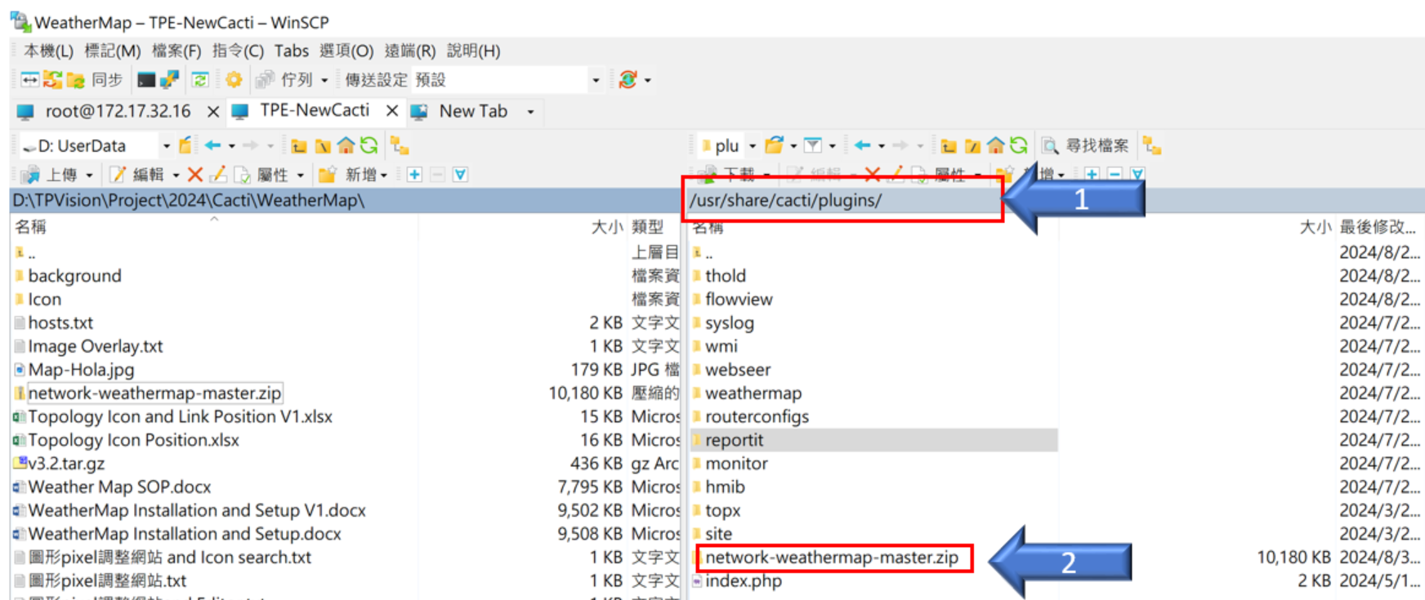

* + 1. Unzip WeatherMap Plugins

Login Cacti server via SSH then unzip WeatherMap zip file and run following command marked with yellow color.

Unzip network-weathermap-master.zip

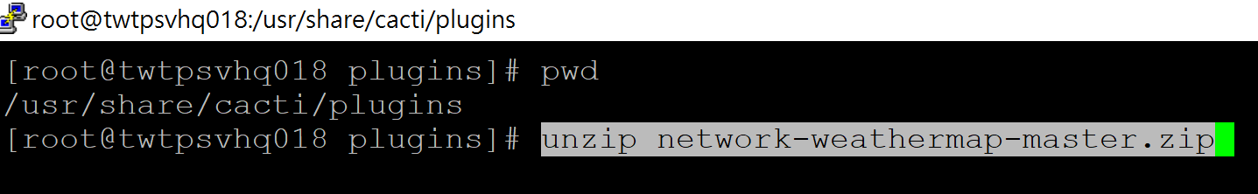

mv network-weathermap-master weathermap

chmod –R 777 weathermap

* + 1. WeatherMap Installation & Active

Login Cacti🡪 Console🡪Configuration🡪 Plugins:

Please click the settings button (gear icon) to install the WeatherMap Plugin, and then enable the WeatherMap Plugin.

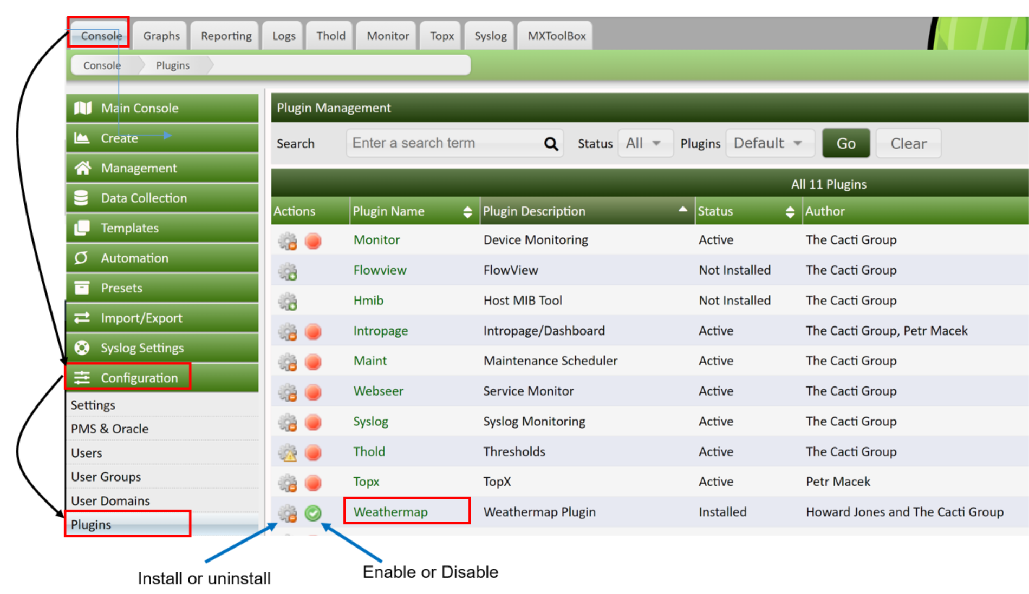

* + 1. WeatherMap Configuration

Select “Console” Tab then navigate to “Management” 🡪 “WeatherMap” to do the network topology setup.

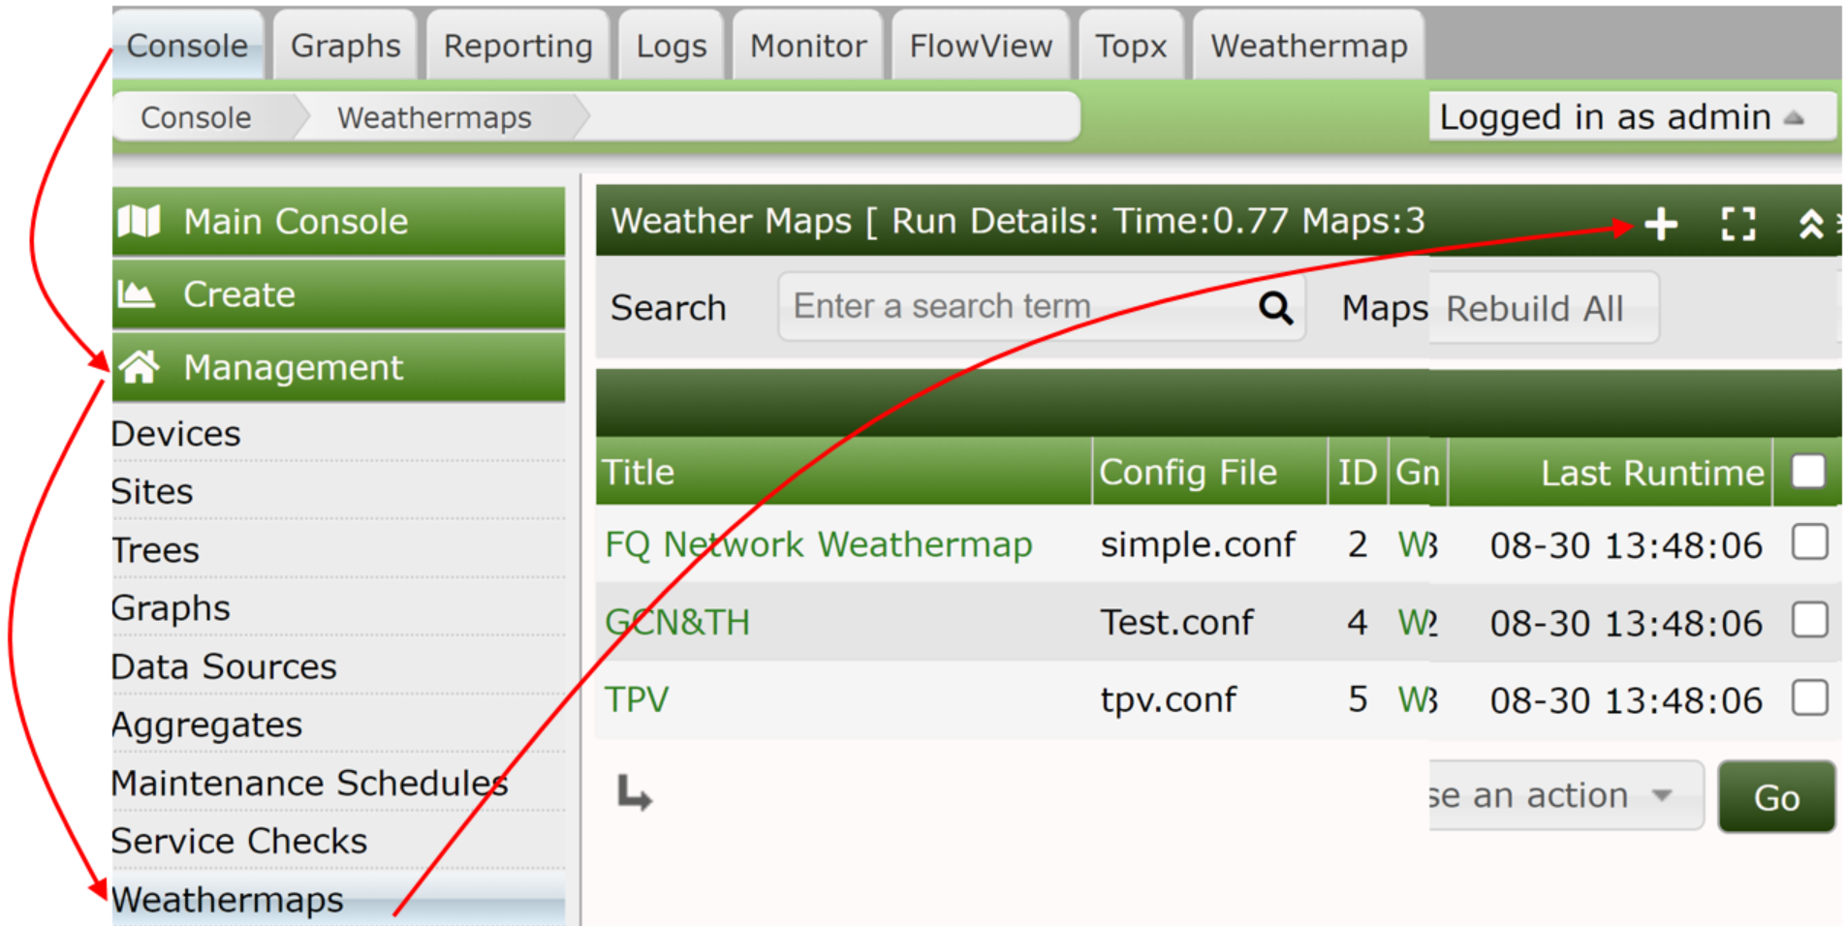

* + 1. WeatherMAP Setup

Select “” button to create new WeatherMap network topology.

Define the Name of WeatherMap and fill it in “New Map” field the select “simple.comf” on “Source Map” option then click “Create” button.

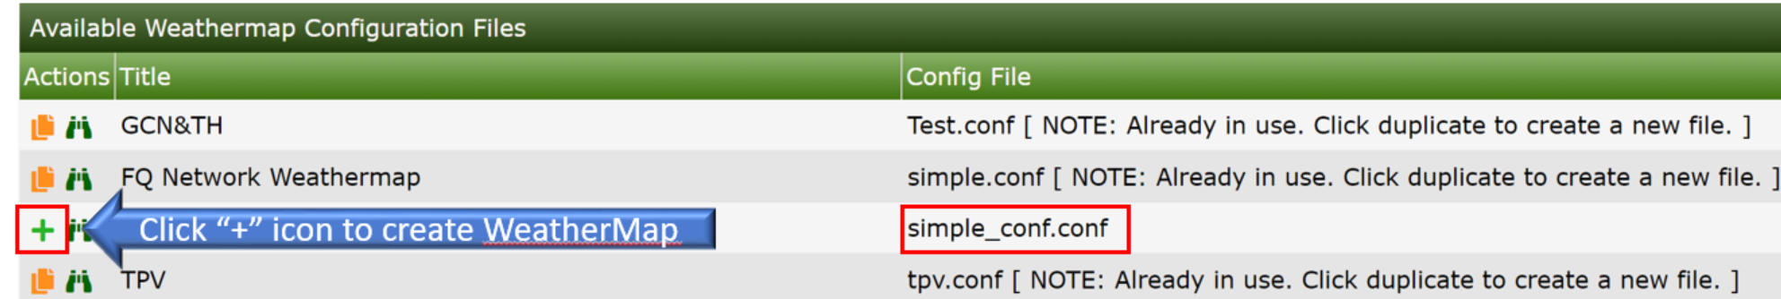

Double click following item to edit WeatherMap.

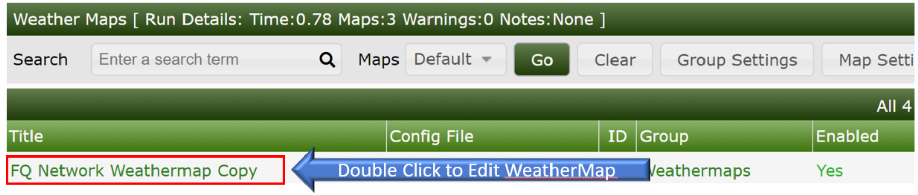

* + 1. WeatherMAP Background change.
* Put the picture (.png or .jpg file) of background to following path on Cacti server for background change.

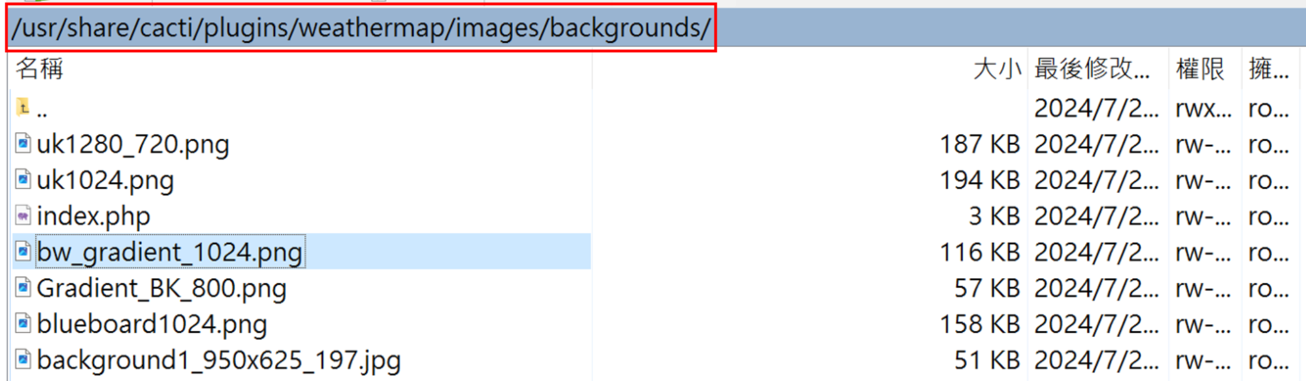

* Click “Map Properties” and select “Background Image Filename “ to

change the background of the Map

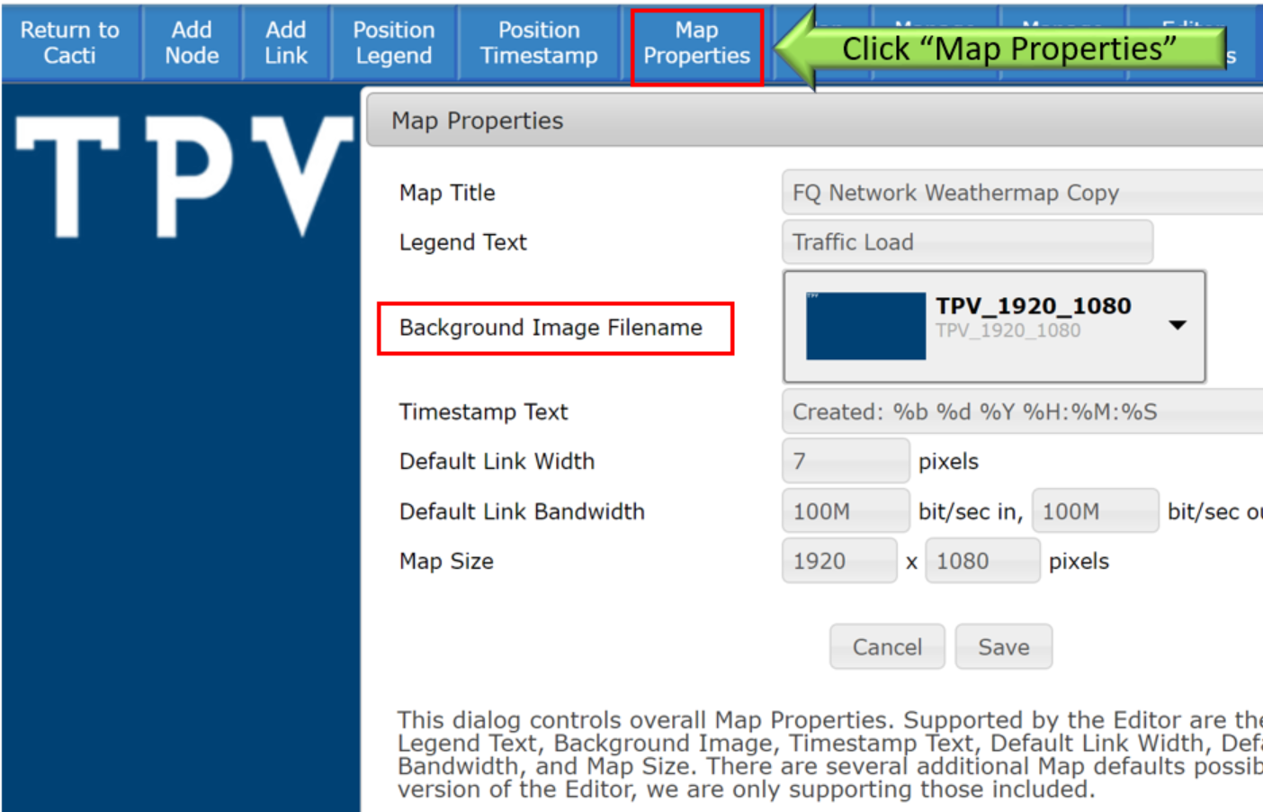

* + 1. WeatherMAP Node Setup.
* Put the picture (.png or .jpg file) of Node’s icon to following path on Cacti server for Node’s icon change.

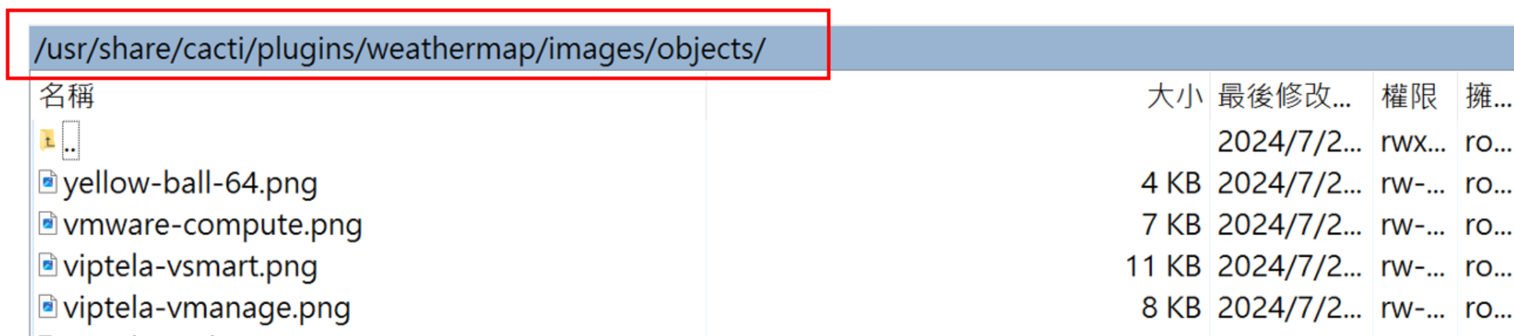

* Click “Add Node” button to create network node on Weatheramp. You can move mouse cursor to put the node location where you want.
* You can double click the “Node” on the map to change Icon or the Label of the Node.

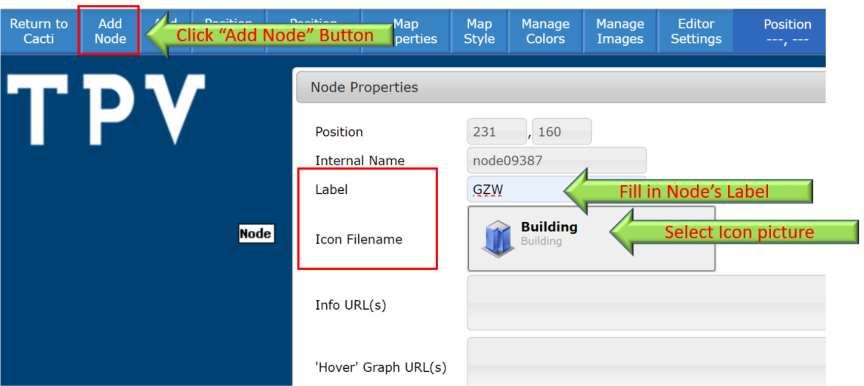

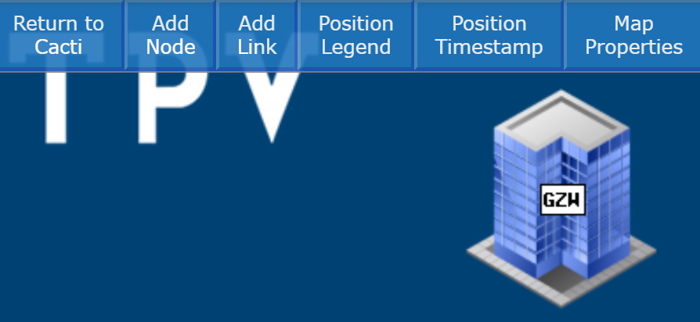

* + 1. WeatherMAP Link Setup.
* Click “Add Link” button to create the connection between Nodes. Click first Icon (PRG) then click 2nd Icon (GZW) then link be created.



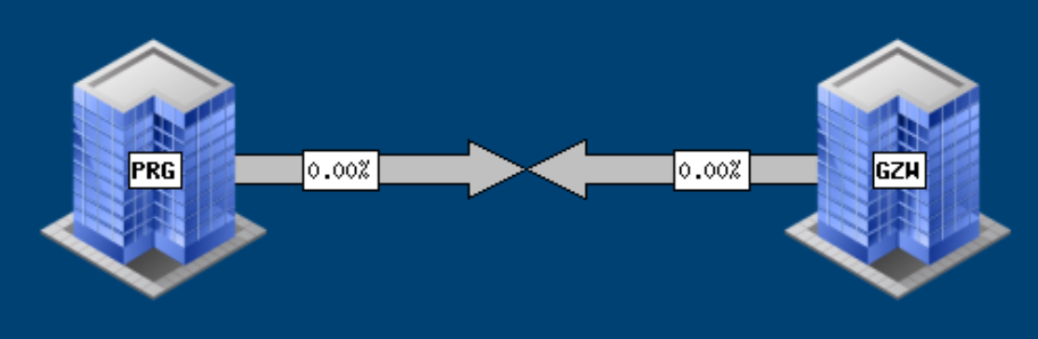

* Click the “Link connection picture” to change the property.

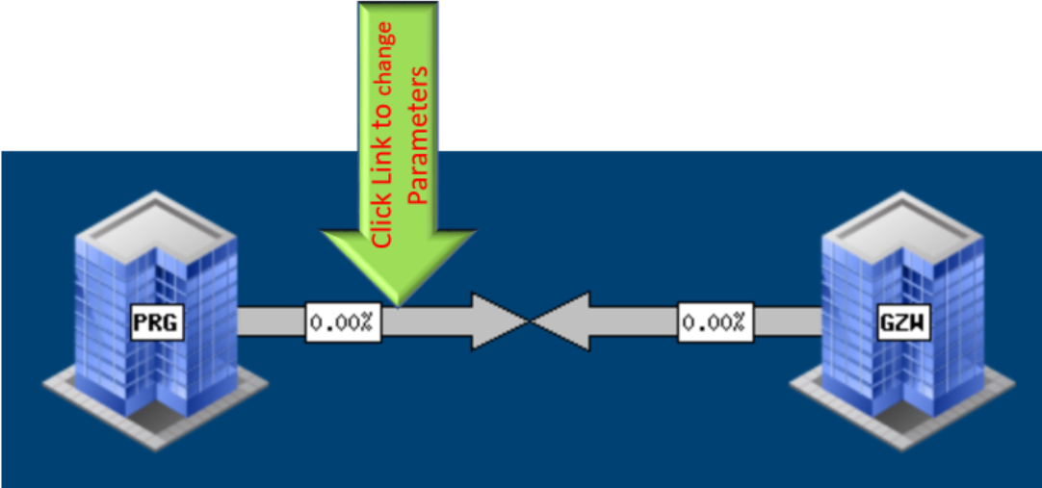

“Maximum Bandwidth”: Fill in the bandwidth of the link.

“Graph Selector”: Fill in a key word then select network graph

which is mapped to this link then the related information will be fill in

“Info URL(s) and “Hover Graph URL(s)” fields automatically.

“Data Source Selector”: Fill in a key word then select then click “Add”

button. RRD file name will be fill in “Data Source” filed automatically.

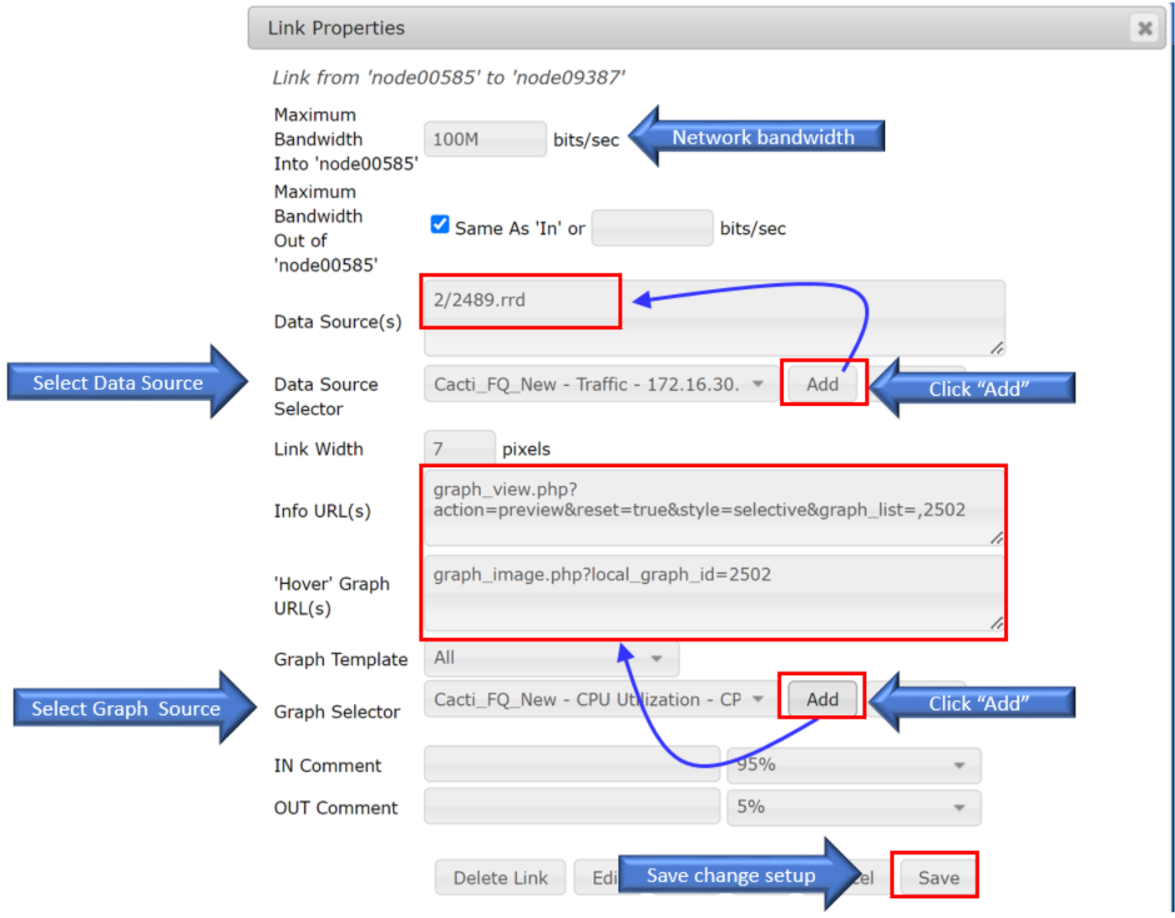

* Click “Save” button after finished above setup.
* Finished ““Hover Graph URL(s)” setup. Link network usage will display when mouse hovers over this link.

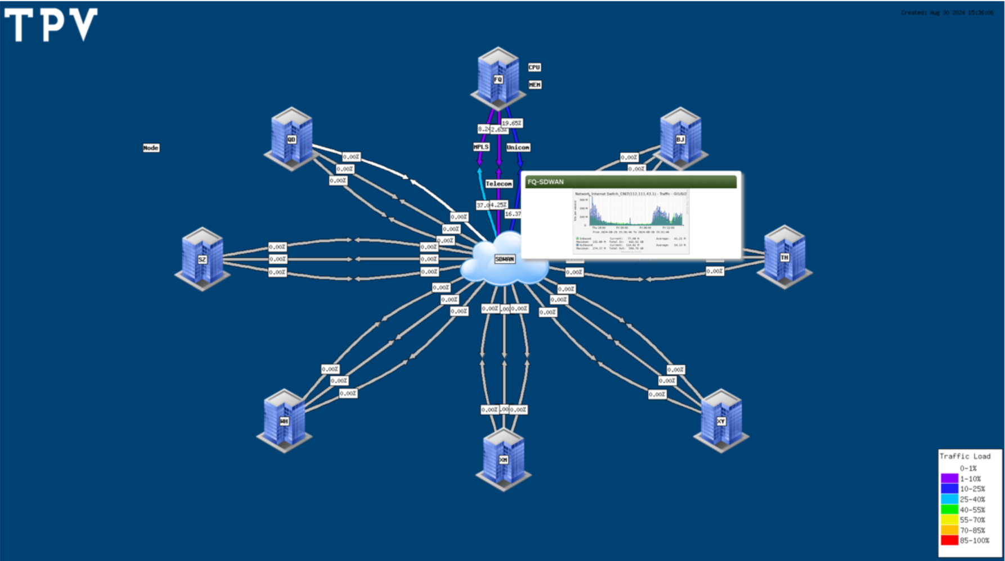

* + 1. WatherMAP Dashboard:
* Click “Weathermap” tab for Weahtmap dashboard selecting. 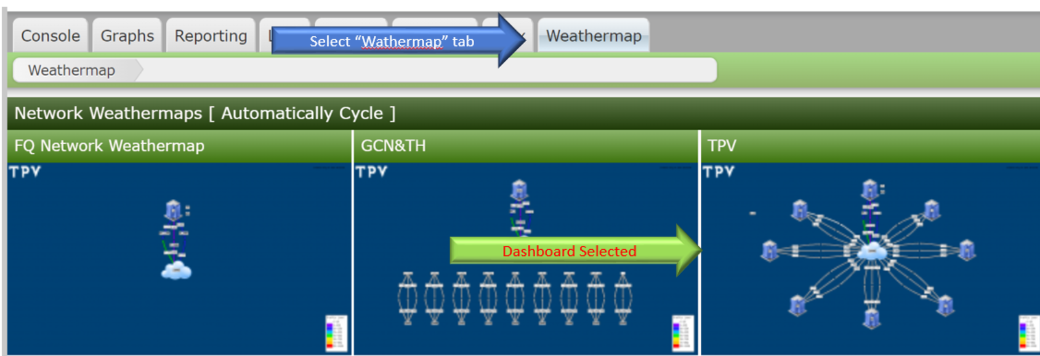
* Dashboard displayed.

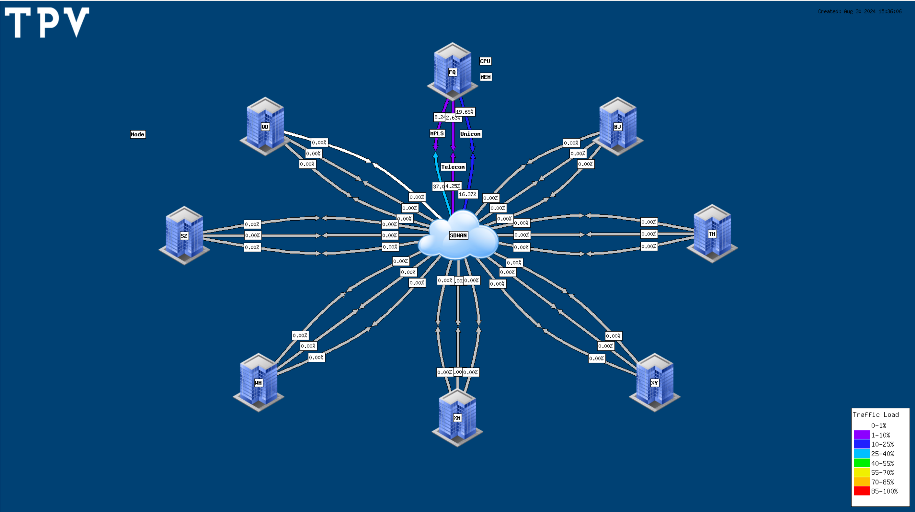

1. **Attachment：**

None.